**LAB REPORT**

**TUTORIAL 1: STAIRCASE PROCEDURE  
PSY310**

**DIYA BAROT  
AU2120073**

**INTRODUCTION**

The staircase approach, often known as the "up/down method," is a method primarily used in experimental psychophysics to determine the absolute threshold at which participants can perceive a given stimuli. Alternative method used to measure threshold is that of method of limits which is more simplistic but less efficient than the staircase method.

The staircase approach is more reliable than other methods since it requires fewer stimuli to be given. Additionally, it doesn't deliver stimuli that are much above or below the threshold value in terms of intensity. Because it is frequently more effective and trustworthy than the other traditional measures used in psychophysics, the staircase technique has thus been widely adopted in recent years.

**PURPOSE**

Determining an individual’s threshold or discrimination ability by adjusting stimulus difficulty based on their performance improves testing efficiency and accuracy.

**METHOD**

The objective of this experiment is to determine, using a staircase approach, the absolute threshold and precision of the participant's capacity to detect the contrast change in visual gratings.

Participant- The test was performed by the experimenter herself as a part of the Lab in Psychology course at Ahmedabad University.

Procedure- the experimenter was sent a video on how to run the experiment and the former performed it on the latest version of PsychoPy on their laptop. The experimenter followed the instructions given by the course professor and performed the experiment step by step.

Pictures of the same have been attached here.

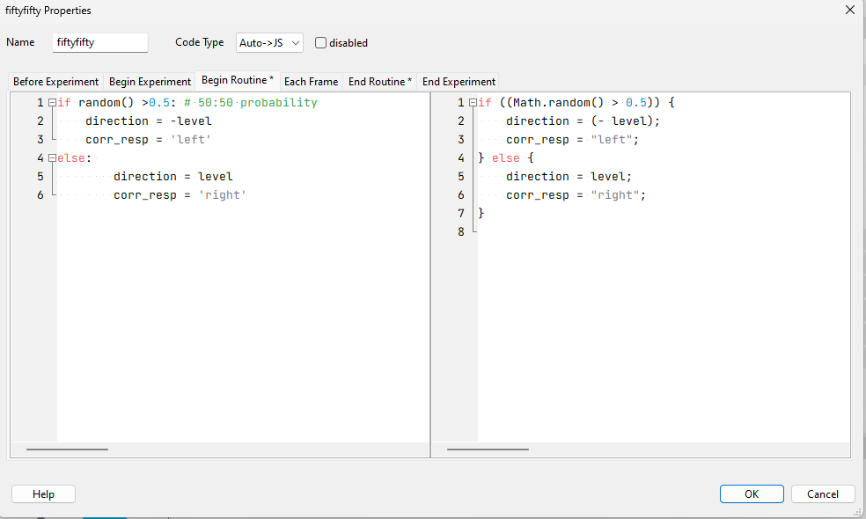

IMAGE 1

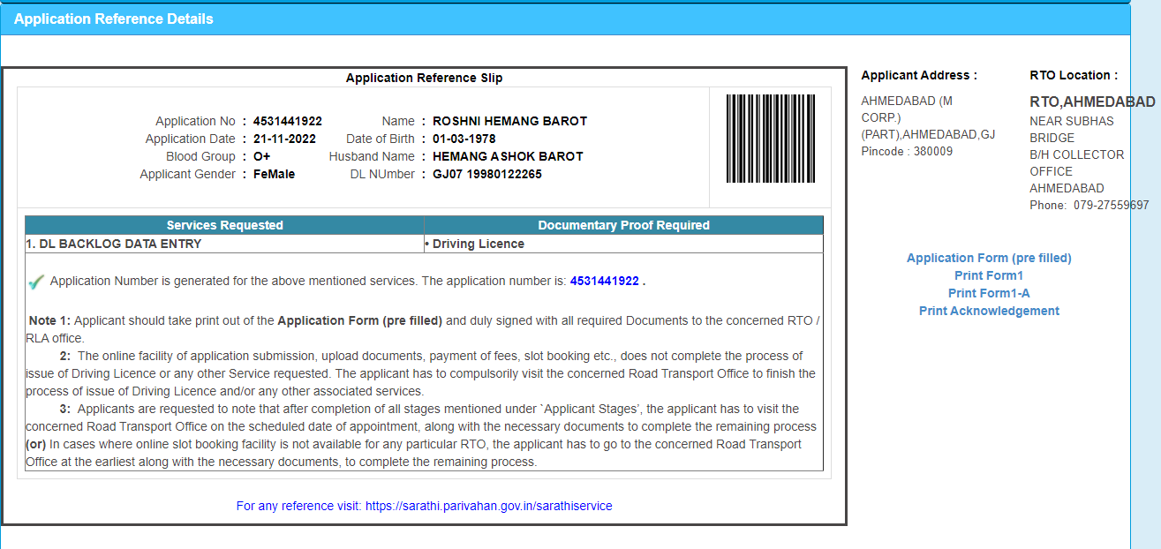

IMAGE 2

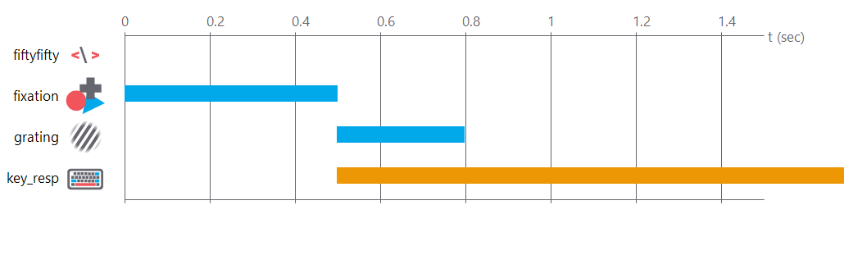

IMAGE 3

Data collection- PsychoPy directly stores the data it gathers during the experiment in a new Excel file within a predefined folder. Hence, the data was stored reliably and then, cleaned to retain values related to the trial intensity and the accuracy of the participant.

**RESULTS**

The threshold value of this adaptive staircase has come up to 6.

**DISCUSSION**

A few limitations of the staircase method are**-**

Subject Variability: Individual participants may differ in their sensitivity and biases in their responses, which can cause subject variation in the outcomes. The staircase method might not adequately take into account these personal variations.

Time-consuming: Staircase techniques frequently include several trials in which the stimulus intensity is changed in response to the participant's reactions. This can take a while, especially if you want to get accurate threshold readings.

Link to GitHub repository- <https://github.com/diyabarotAU2120073/DIYABAROT/upload/main>